Elements of Dance: Energy
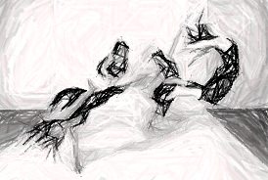
Energy helps us to identify how the dancers move. What quality are they using? Perhaps their movements are sharp and strong, or maybe they are light and free. Energy also represents the force of the movement—its power and weight. For choreographers and dancers, there are many possibilities.
The quality the dancers use can communicate meaning, depending on the energy involved. A touch between two dancers may be gentle and light, perhaps indicating concern or affection; or it may be sudden and forceful, indicating anger or playfulness. Energy is crucial in bringing the inner expression of emotion out to the stage performance.
Dance has its own content, vocabulary, skills, and techniques, which must be understood and applied to be proficient in the art. The elements of dance are the foundational concepts and vocabulary for developing movement skills as well as understanding dance as an art form. All these elements are simultaneously present in a dance or even in a short movement phrase.
In Physics, energy refers to the capacity to do work. Dancers certainly need to possess this capacity in order to perform movements. Energy in dance refers to a wide array of variables, but can mainly be categorized into two kinds, force and quality. Whenever a mover executes a movement, it not only exists in time and space, but also inherently possesses a quality and amount of effort, or energy. These are described below.
How much energy is being used: Force is usually defined as a scale of Force: Heavy to light.
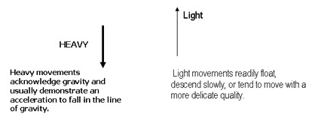
Force in dance can also be manifested as strength (Bound to free), emphasizing the muscular effort or resistance through space. The effect of achieving less force would be exemplified by emphasis on the ease of the joints and their movements, and imagining the bones moving in space, rather than the muscles that pull on them.

1. According to the article, what does “quality of energy” mean?
2. What is your opinion of the statement: “Dance has its own content, vocabulary, skills, and techniques, which must be understood and applied to be proficient in the art?”
3. Explain dance “force” in one complete, concise sentence:

