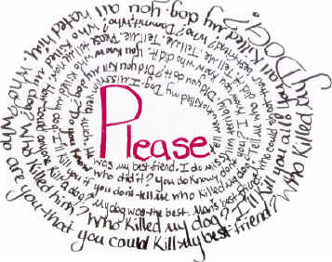
The Issues:
Violent and Threatening Imagery
Artistic Expression in Public Schools

In 1969, the U.S. Supreme Court determined that "true threats" of violence was among those categories of speech that are not protected by the First Amendment. What constitutes such a "true threat," however, is often difficult to distinguish from constitutionally protected speech. Although lower federal and state courts have adopted varying legal standards for making this determination, all rely heavily on the context in which the expression took place. Thus, expression that is reasonably understood to be an artistic statement is protected by the First Amendment even if it depicts disturbing acts of violence. On the other hand, expression that a speaker does not intend as a threat, but a listener reasonably interprets as such, may be punishable.
In the context of public schools, the U.S. Supreme Court has determined that students do not "shed their constitutional rights to freedom of speech or expression at the schoolhouse gate." Yet the Supreme Court has made it equally clear that school authorities have a strong and valid interest in maintaining discipline and carrying out their educational mission. The pursuit of these goals sometimes allows restrictions on speech within the public school context that would not be tolerated elsewhere. As a result, lower courts often give great deference to the decisions of school administrators, sustaining their actions so long as they are reasonably related to a legitimate educational goal. One such goal, preventing disruption of the school environment, has often been cited as the justification for punishing students who create an artistic work that school administrators find threatening or otherwise inappropriate for the school setting.
The Case: Boman v. Bluestem Unified School District No. 205

In 2000, seventeen year-old high school senior Sarah Boman created a poster for her art class at Bluestem High School in Leon, Kansas. The poster contains a narrative, written in the first person, exploring the question, "Who killed my dog?" The narrative (text below) was not presented in the traditional format of left to right but rather in a clockwise spiral making it somewhat difficult to read. Included in the narrative were the statements, "I'll kill you if you don't tell me who killed my dog," and "I'll kill you all!" Boman, an accomplished art student, stated her piece was a work of art that reflected no personal experience with a dog.

Initially, Boman was permitted to hang the poster on a door in a school hallway. The school's principal subsequently saw the poster, found it disturbing, seized it, and ordered an investigation. A few days later, Boman was suspended from school for the remainder of the year, approximately 81.5 days. Despite the conclusions of the school district's investigator that Boman did not intend to threaten anyone and that the suspension should be dropped, the Bluestem Board of Education ordered that she undergo (and "pass") a psychological evaluation before being allowed back in school. Boman sued the school district in federal court for an injunction to return to school. The U.S. District Court for the District of Kansas granted the injunction, finding that Boman's work neither constituted a threat nor caused a substantial disruption at her school.
1. Write two arguments in support of the student artist’s rights to hang the poster.
2. Write two arguments in support of the principal’s decision to suspend the student.

